**EXPRIMENT NO-10**

**CSA1142-OBJECT ORIENTED ANALYSIS AND DESIGN**

**RECUIRTMENT MANAGMENT SYSTEM**

**USE CASE**

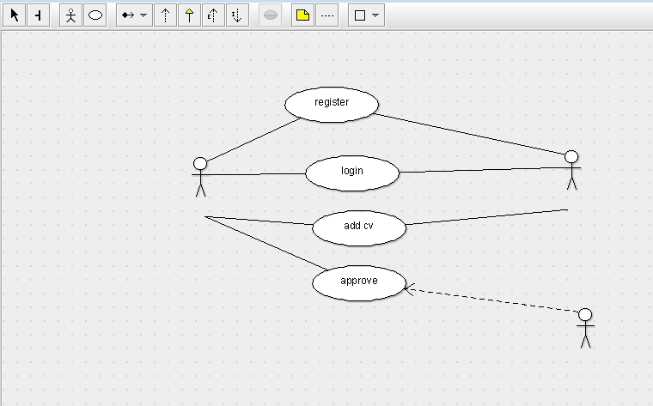

STATE DIAAGRAM

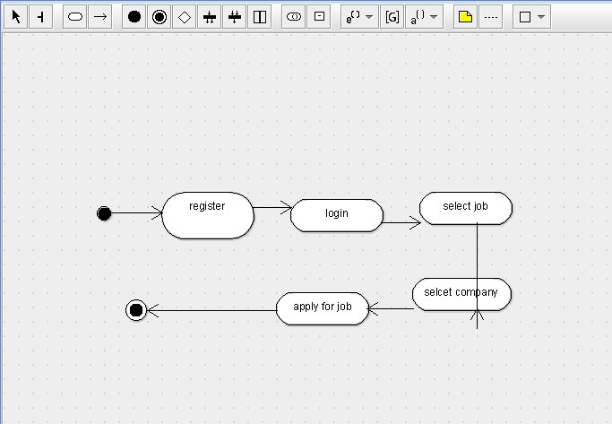

SEQUENCE DIAGRAM

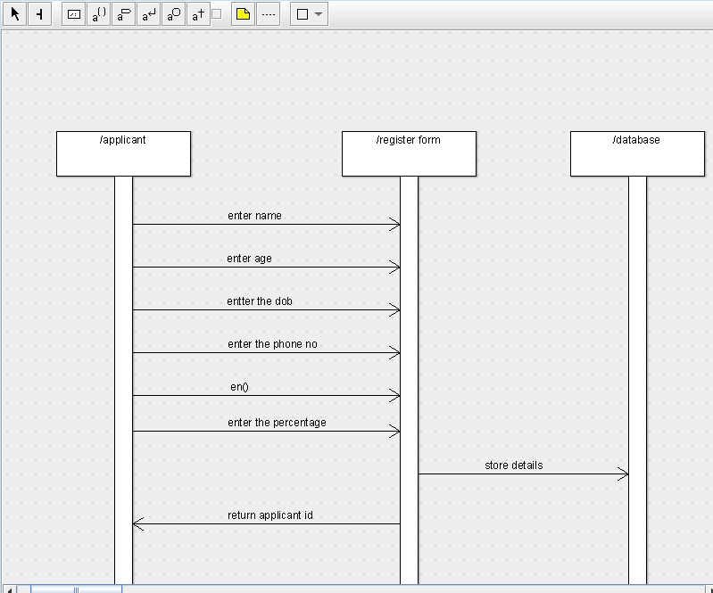

DEPLOYMENT DIAGRAM

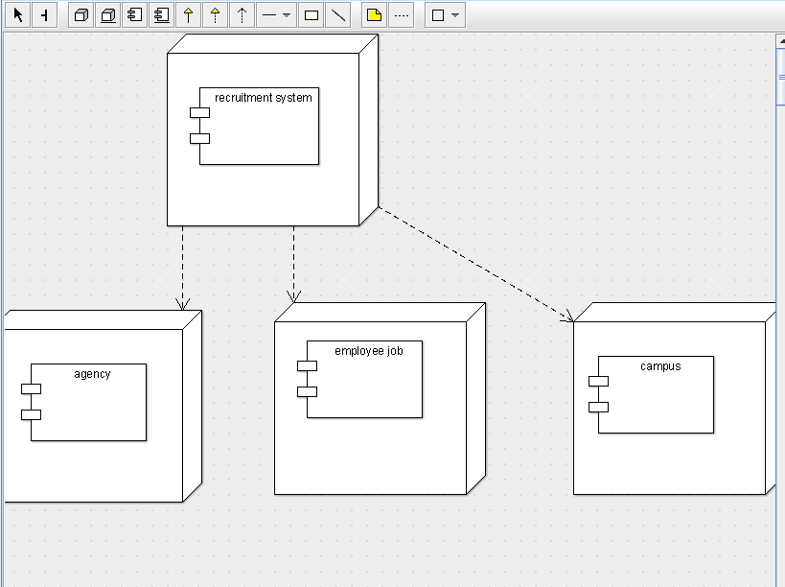

COMPONENT DIAGRAM

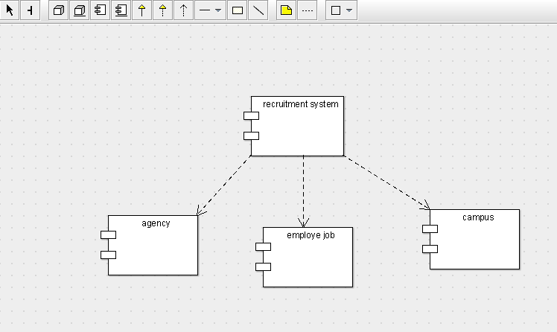

COLLABORATION DIAGRAM

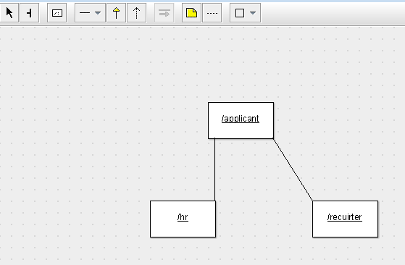

CLASS DIAGRAM

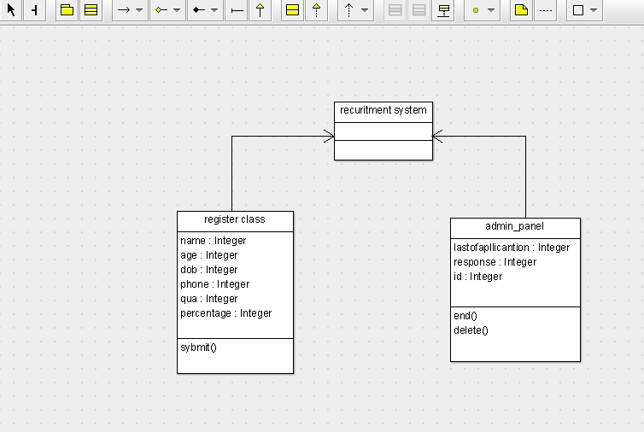

ACTIVITY DIAGRAM

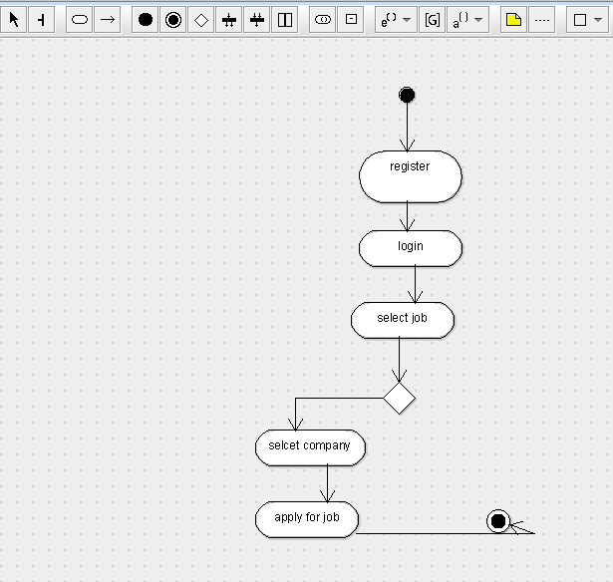

SKELETON CODE;

public class recuritment system {

}

import java.util.Vector;

public class admin_panel {

  public Integer lastofapllicantion;

  public Integer response;

  public Integer id;

    public Vector  myrecuritment system;

  private void end() {

  }

  public void delete() {

  }

}

import java.util.Vector;

public class register class {

  public Integer name;

  public Integer age;

  public Integer dob;

  public Integer phone;

  public Integer qua;

  public Integer percentage;

    public Vector  myrecuritment system;

  public void sybmit() {

  }

}